COMP122 – E-commerce Database Project
Student Names: Asim Kayani
Adetoun Adewusi
Ryan Baboolal
Course: COMP122
Date: April 2026
- Requirement Analysis
1.1 Purpose

The purpose of this database is to support an e-commerce system that stores and manages information about users, products, categories, vendors, orders, wishlists, and returns. The system is designed to support business needs, satisfy user requirements, and provide accurate information in a useful format for customers, employees, and vendors.

  - Stakeholders

The main stakeholders of the system are:
• Customers / Users
• Vendors / Suppliers
• Store Manager / Business Owner
• System Administrator

  - Functional Requirements

The system should be able to:
• register a new user
• unregister or deactivate a user
• store and manage user details
• display products by category
• store product information such as name, price, category, and vendor
• allow users to place orders
• store order details and order items
• track shipping status of orders
• allow users to add items to a Wishlist
• show all items in a user’s Wishlist
• manage vendor details
• process product returns
• record refund information
• generate monthly sales reports
• identify the most popular products
• categorize customers based on purchase history

1.4 Non-Functional Requirements

The system should:
• be easy to use
• provide accurate and consistent data
• maintain data integrity using primary keys and foreign keys
• support fast retrieval of information
• be reliable and well organized
• protect important customer and business data
• produce clear and meaningful results

1.5 Types of Data to Store

The database should store the following data:
• user information: user ID, first name, last name, email, password, phone, address, status
• category information: category ID, category name
• vendor information: vendor ID, vendor name, contact name, phone, email, address, status
• product information: product ID, product name, price, category ID, vendor ID
• order information: order ID, user ID, order date, total amount, shipping status
• order item information: order item ID, order ID, product ID, quantity
• wishlist information: wishlist ID, user ID, product ID
• return information: return ID, order item ID, refund amount, return status

1.6 Expected Queries and Reports

The system should support the following queries and reports:
• search products based on category
• manage shopping cart / order items
• register and unregister users
• track shipping status
• manage vendor information
• generate monthly sales reports
• identify the most popular products
• categorize customers based on purchase history
• list all items on a user’s wishlist
• handle returns and refunds

1.7 Business Rules

The following business rules apply to the system:
• one user can place many orders
• each order belongs to one user
• one order can contain many order items
• each order item belongs to one order
• one product can appear in many order items
• each order item refers to one product
• one user can have many wishlist entries
• each wishlist entry belongs to one user
• one product can appear in many wishlist entries
• each wishlist entry refers to one product
• one category can contain many products
• each product belongs to one category
• one vendor can supply many products
• each product belongs to one vendor
• one order item can be linked to return information
• each return record belongs to one order item

1.8 Use Cases

The main use cases of the system are:
• register user
• unregister user
• browse products
• search products by category
• view product details
• place order
• add items to order
• view order history
• track shipping status
• add item to wishlist
• view wishlist
• manage vendor details
• return product
• process refund
• generate monthly report
• identify popular product
• categorize customer by purchase history

1.9 Workflows

Workflow 1: User Registration
1. User enters personal information.
2. System stores the user data in the USERS table.
3. A new user account is created.

Workflow 2: Search Products by Category
1. User selects a category.
2. System checks the CATEGORIES table.
3. System retrieves matching products from the PRODUCTS table.
4. Matching products are displayed.

Workflow 3: Place Order
1. User selects products.
2. System creates a new order in the ORDERS table.
3. Selected products are stored in ORDER_ITEMS.
4. Order total and shipping status are recorded.

Workflow 4: Wishlist Management
1. User selects a product.
2. System stores the item in the WISHLIST table.
3. User can later view all wishlist items.

Workflow 5: Shipping Status Tracking
1. User selects an order.
2. System checks the ORDERS table.
3. The current shipping status is displayed.

Workflow 6: Return and Refund
1. User requests a return for a purchased item.
2. System stores the return in the RETURNS table.
3. Refund amount and return status are recorded.
4. Updated return information is displayed.

Workflow 7: Monthly Sales Report
1. System checks order records in the ORDERS table.
2. Orders are grouped by month.
3. Monthly sales totals are calculated.
4. The report is displayed.

Workflow 8: Most Popular Product
1. System checks product frequency in ORDER_ITEMS.
2. Ordered quantities or occurrences are counted.
3. The most popular product is identified.
4. The result is displayed.

Workflow 9: Customer Categorization
1. System checks customer orders in the ORDERS table.
2. Total purchases or order frequency is calculated.
3. Customers are categorized based on their purchase history.
4. The result is displayed.

1.10 Output

The output of this phase is a Requirement Analysis document that explains the purpose of the system, identifies stakeholders, defines data requirements, describes business rules, and supports the design of the ER diagram and database tables.

2. Entity Relationship Diagram (ERD)
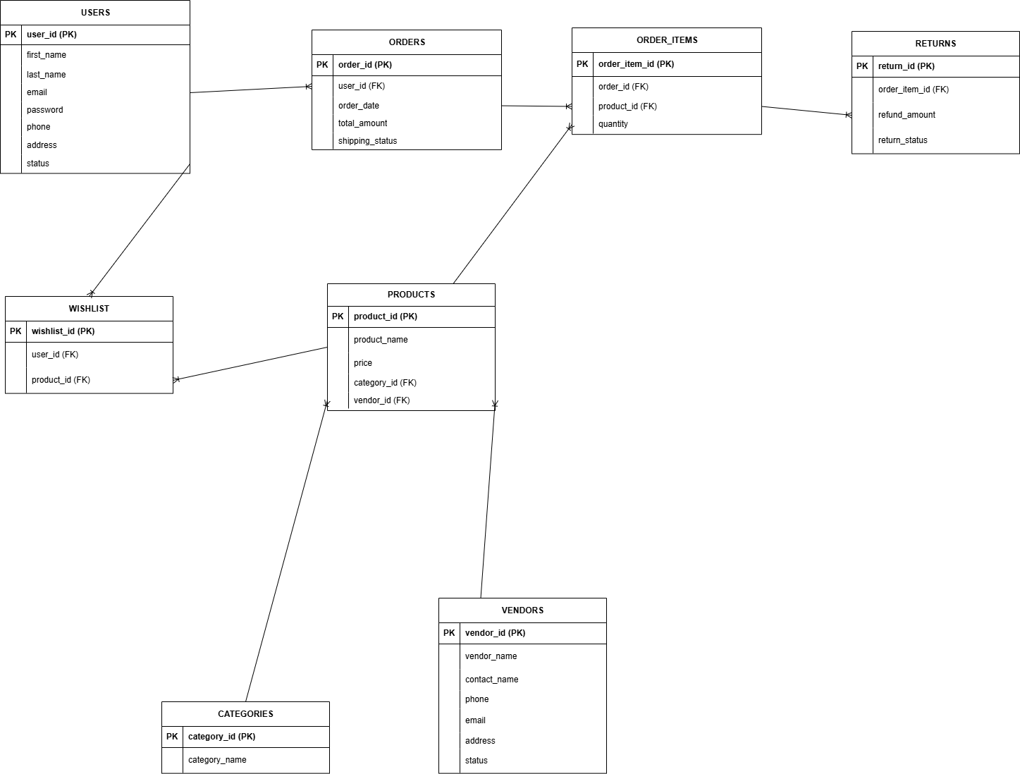
3. Logical Design

3.1 Purpose

The purpose of the logical design is to translate the conceptual ERD into a relational database structure. In this phase, each entity in the ERD is converted into a table, attributes are converted into columns, and relationships are implemented through primary keys and foreign keys. The schema is normalized to reduce redundancy and enforce data integrity. Appropriate data types and constraints are also defined to ensure the accuracy and consistency of the data.
3.2 Normalization
The schema is normalized to reduce redundancy and avoid unnecessary duplication of data. Data is separated into related tables such as USERS, PRODUCTS, ORDERS, ORDER_ITEMS, CATEGORIES, VENDORS, WISHLIST, and RETURNS. This design improves consistency, reduces update anomalies, and supports efficient storage and retrieval of information.
3.3 Logical Schema (Normalized Table Structure)
USERS
CREATE TABLE USERS (
user_id NUMBER,
first_name VARCHAR2(50) NOT NULL,
last_name VARCHAR2(50) NOT NULL,
email VARCHAR2(100) NOT NULL,
password VARCHAR2(100) NOT NULL,
phone VARCHAR2(20),
address VARCHAR2(150),
status VARCHAR2(20) NOT NULL,

CONSTRAINT pk_users PRIMARY KEY (user_id),
CONSTRAINT uq_users_email UNIQUE (email),
CONSTRAINT chk_users_status CHECK (status IN ('Active', 'Inactive'))
);
CATEGORIES
CREATE TABLE CATEGORIES (
category_id NUMBER,
category_name VARCHAR2(100) NOT NULL,

CONSTRAINT pk_categories PRIMARY KEY (category_id),
CONSTRAINT uq_categories_name UNIQUE (category_name)
);
VENDORS
CREATE TABLE VENDORS (
vendor_id NUMBER,
vendor_name VARCHAR2(100) NOT NULL,
contact_name VARCHAR2(100) NOT NULL,
phone VARCHAR2(20),
email VARCHAR2(100) NOT NULL,
address VARCHAR2(150),
status VARCHAR2(20) NOT NULL,

CONSTRAINT pk_vendors PRIMARY KEY (vendor_id),
CONSTRAINT uq_vendors_email UNIQUE (email),
CONSTRAINT chk_vendors_status CHECK (status IN ('Active', 'Inactive'))
);
PRODUCTS
CREATE TABLE PRODUCTS (
product_id NUMBER,
product_name VARCHAR2(100) NOT NULL,
price NUMBER(10,2) NOT NULL,
category_id NUMBER NOT NULL,
vendor_id NUMBER NOT NULL,

CONSTRAINT pk_products PRIMARY KEY (product_id),
CONSTRAINT chk_products_price CHECK (price > 0),
CONSTRAINT fk_products_category FOREIGN KEY (category_id)
REFERENCES CATEGORIES(category_id),
CONSTRAINT fk_products_vendor FOREIGN KEY (vendor_id)
REFERENCES VENDORS(vendor_id)
);
ORDERS
CREATE TABLE ORDERS (
order_id NUMBER,
user_id NUMBER NOT NULL,
order_date DATE NOT NULL,
total_amount NUMBER(10,2) NOT NULL,
shipping_status VARCHAR2(30) NOT NULL,

CONSTRAINT pk_orders PRIMARY KEY (order_id),
CONSTRAINT chk_orders_total CHECK (total_amount >= 0),
CONSTRAINT chk_orders_shipping_status CHECK (
shipping_status IN ('Pending', 'Shipped', 'Delivered', 'Cancelled')
),
CONSTRAINT fk_orders_user FOREIGN KEY (user_id)
REFERENCES USERS(user_id)
);
ORDER_ITEMS
CREATE TABLE ORDER_ITEMS (
order_item_id NUMBER,
order_id NUMBER NOT NULL,
product_id NUMBER NOT NULL,
quantity NUMBER NOT NULL,

CONSTRAINT pk_order_items PRIMARY KEY (order_item_id),
CONSTRAINT chk_order_items_quantity CHECK (quantity > 0),
CONSTRAINT fk_order_items_order FOREIGN KEY (order_id)
REFERENCES ORDERS(order_id),
CONSTRAINT fk_order_items_product FOREIGN KEY (product_id)
REFERENCES PRODUCTS(product_id)
);
WISHLIST
CREATE TABLE WISHLIST (
wishlist_id NUMBER,
user_id NUMBER NOT NULL,
product_id NUMBER NOT NULL,

CONSTRAINT pk_wishlist PRIMARY KEY (wishlist_id),
CONSTRAINT fk_wishlist_user FOREIGN KEY (user_id)
REFERENCES USERS(user_id),
CONSTRAINT fk_wishlist_product FOREIGN KEY (product_id)
REFERENCES PRODUCTS(product_id)
);
RETURNS
CREATE TABLE RETURNS (
return_id NUMBER,
order_item_id NUMBER NOT NULL,
refund_amount NUMBER(10,2) NOT NULL,
return_status VARCHAR2(30) NOT NULL,

CONSTRAINT pk_returns PRIMARY KEY (return_id),
CONSTRAINT chk_returns_refund CHECK (refund_amount >= 0),
CONSTRAINT chk_returns_status CHECK (
return_status IN ('Requested', 'Approved', 'Rejected', 'Refunded')
),
CONSTRAINT fk_returns_order_item FOREIGN KEY (order_item_id)
REFERENCES ORDER_ITEMS(order_item_id)
);
3.4 Relationship Implementation
The relationships from the ERD are implemented in the logical schema through foreign key constraints, as follows:
• One user can place many orders, implemented by ORDERS.user_id referencing USERS.user_id
• One user can have many wishlist entries, implemented by WISHLIST.user_id referencing USERS.user_id
• One order can contain many order items, implemented by ORDER_ITEMS.order_id referencing ORDERS.order_id
• One product can appear in many order items, implemented by ORDER_ITEMS.product_id referencing PRODUCTS.product_id
• One product can appear in many wishlist entries, implemented by WISHLIST.product_id referencing PRODUCTS.product_id
• One category can contain many products, implemented by PRODUCTS.category_id referencing CATEGORIES.category_id
• One vendor can supply many products, implemented by PRODUCTS.vendor_id referencing VENDORS.vendor_id
• One order item can be associated with return information, implemented by RETURNS.order_item_id referencing ORDER_ITEMS.order_item_id

3.5 Constraints Used

The following constraints are used in the logical design:
• Primary Key constraints to uniquely identify each record in every table
• Foreign Key constraints to enforce relationships between related tables
• NOT NULL constraints to ensure mandatory data is entered
• UNIQUE constraints to prevent duplicate values in attributes such as email and category name
• CHECK constraints to restrict values such as price, quantity, status, shipping status, and refund amount

3.6 Output
The output of this phase is the logical schema and normalized table structure of the e-commerce database. The logical design clearly defines the tables, attributes, data types, and constraints needed to implement the database in a relational DBMS. This provides the foundation for the next phase, which is implementation in Oracle. ￼

3.7 Conclusion

The logical design successfully converts the conceptual ERD into a structured relational schema. The database is normalized to reduce redundancy, and integrity is enforced through primary keys, foreign keys, unique constraints, not null constraints, and check constraints. This ensures that the database design is consistent, reliable, and ready for implementation.
4. Implementation
4.1 Purpose
The purpose of this phase is to build and deploy the database using Oracle. SQL scripts are written and executed to create tables, define constraints, and insert sample data. The result is an operational database that supports the system requirements.
4.2 Table Creation (SQL Execution)
USERS
CREATE TABLE USERS (
user_id NUMBER,
first_name VARCHAR2(50) NOT NULL,
last_name VARCHAR2(50) NOT NULL,
email VARCHAR2(100) NOT NULL,
password VARCHAR2(100) NOT NULL,
phone VARCHAR2(20),
address VARCHAR2(150),
status VARCHAR2(20) NOT NULL,
CONSTRAINT pk_users PRIMARY KEY (user_id),
CONSTRAINT uq_users_email UNIQUE (email),
CONSTRAINT chk_users_status CHECK (status IN ('Active', 'Inactive'))
);

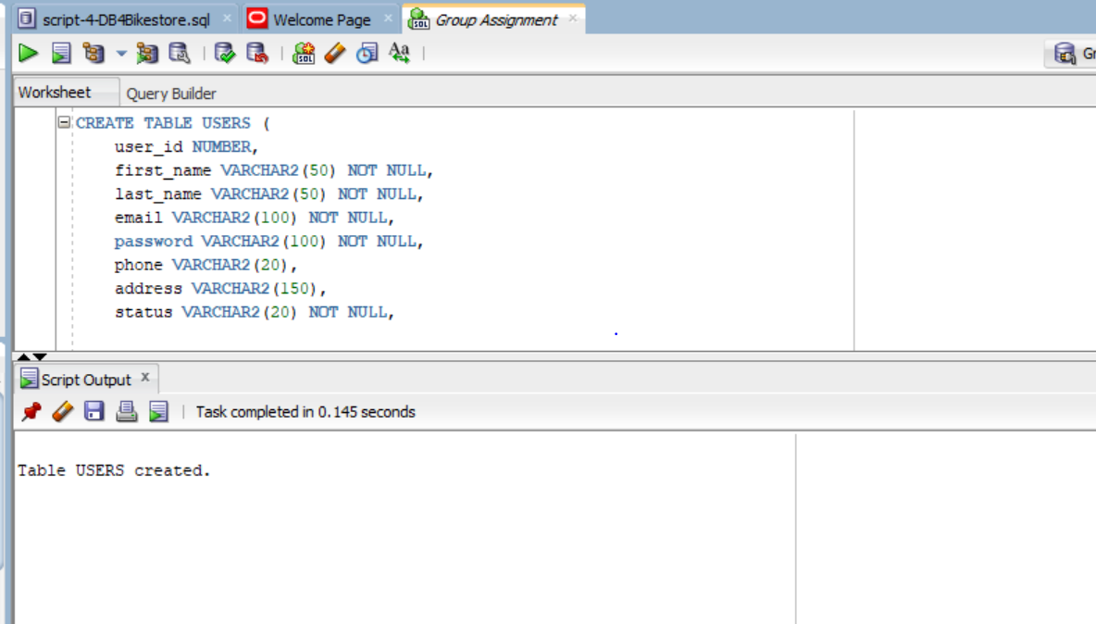
CATEGORIES
CREATE TABLE CATEGORIES (
category_id NUMBER,
category_name VARCHAR2(100) NOT NULL,

CONSTRAINT pk_categories PRIMARY KEY (category_id),
CONSTRAINT uq_categories_name UNIQUE (category_name)
);
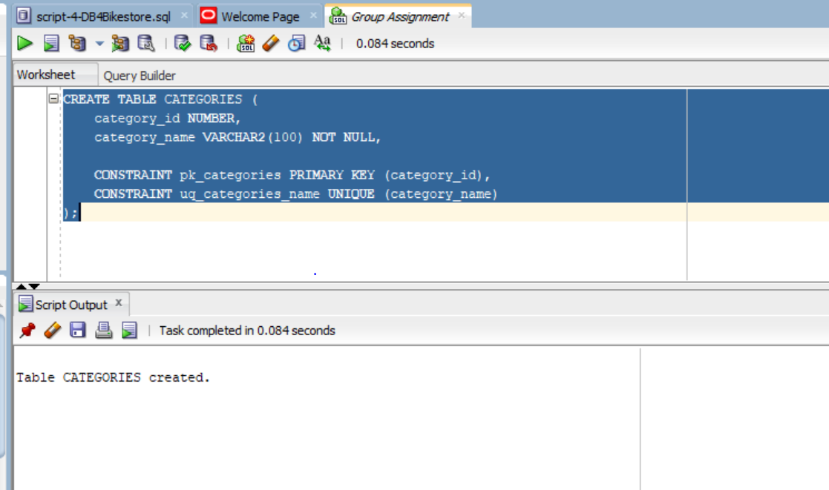
VENDORS
CREATE TABLE VENDORS (
vendor_id NUMBER,
vendor_name VARCHAR2(100) NOT NULL,
contact_name VARCHAR2(100) NOT NULL,
phone VARCHAR2(20),
email VARCHAR2(100) NOT NULL,
address VARCHAR2(150),
status VARCHAR2(20) NOT NULL,

CONSTRAINT pk_vendors PRIMARY KEY (vendor_id),
CONSTRAINT uq_vendors_email UNIQUE (email),
CONSTRAINT chk_vendors_status CHECK (status IN ('Active', 'Inactive'))
);
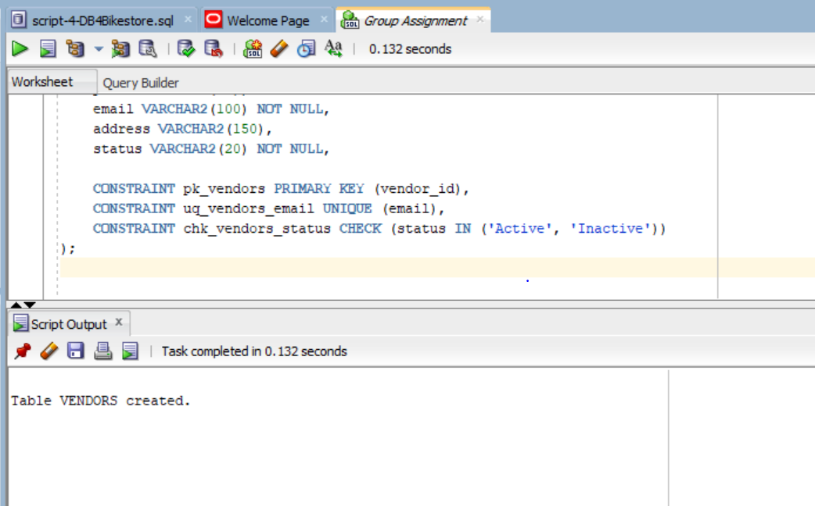
PRODUCTS
CREATE TABLE PRODUCTS (
product_id NUMBER,
product_name VARCHAR2(100) NOT NULL,
price NUMBER(10,2) NOT NULL,
category_id NUMBER NOT NULL,
vendor_id NUMBER NOT NULL,

CONSTRAINT pk_products PRIMARY KEY (product_id),
CONSTRAINT chk_products_price CHECK (price > 0),
CONSTRAINT fk_products_category FOREIGN KEY (category_id)
REFERENCES CATEGORIES(category_id),
CONSTRAINT fk_products_vendor FOREIGN KEY (vendor_id)
REFERENCES VENDORS(vendor_id)
);
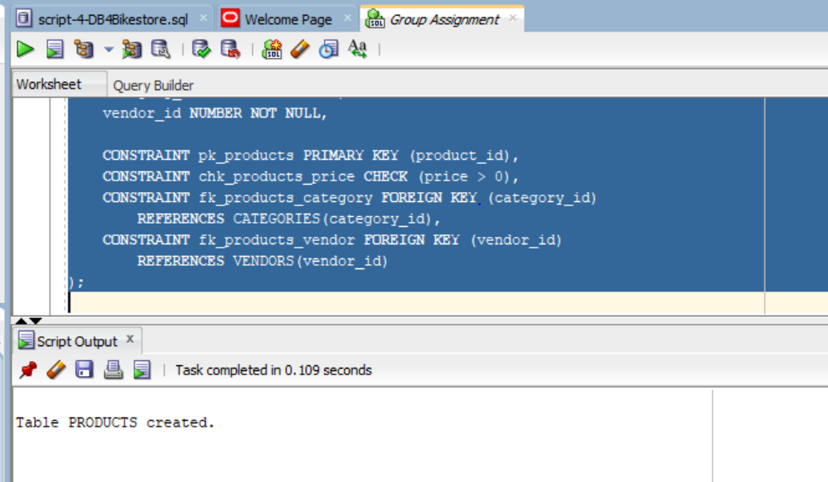
ORDERS
CREATE TABLE ORDERS (
order_id NUMBER,
user_id NUMBER NOT NULL,
order_date DATE NOT NULL,
total_amount NUMBER(10,2) NOT NULL,
shipping_status VARCHAR2(30) NOT NULL,

CONSTRAINT pk_orders PRIMARY KEY (order_id),
CONSTRAINT chk_orders_total CHECK (total_amount >= 0),
CONSTRAINT chk_orders_shipping_status CHECK (
shipping_status IN ('Pending', 'Shipped', 'Delivered', 'Cancelled')
),
CONSTRAINT fk_orders_user FOREIGN KEY (user_id)
REFERENCES USERS(user_id)
);
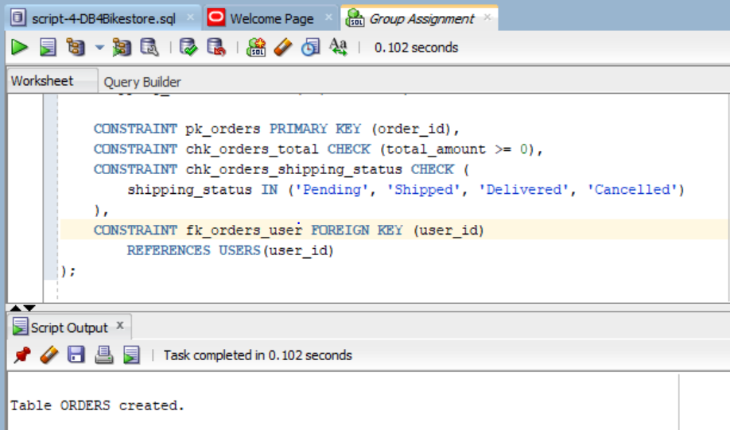
ORDER_ITEMS
CREATE TABLE ORDER_ITEMS (
order_item_id NUMBER,
order_id NUMBER NOT NULL,
product_id NUMBER NOT NULL,
quantity NUMBER NOT NULL,

CONSTRAINT pk_order_items PRIMARY KEY (order_item_id),
CONSTRAINT chk_order_items_quantity CHECK (quantity > 0),
CONSTRAINT fk_order_items_order FOREIGN KEY (order_id)
REFERENCES ORDERS(order_id),
CONSTRAINT fk_order_items_product FOREIGN KEY (product_id)
REFERENCES PRODUCTS(product_id)
);
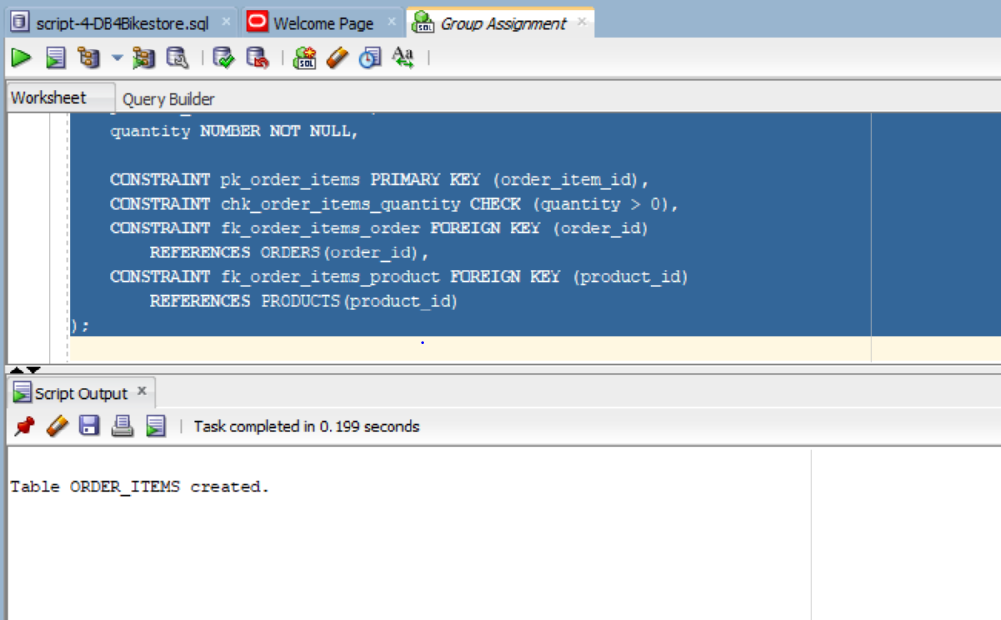
WISHLIST
CREATE TABLE WISHLIST (
wishlist_id NUMBER,
user_id NUMBER NOT NULL,
product_id NUMBER NOT NULL,

CONSTRAINT pk_wishlist PRIMARY KEY (wishlist_id),
CONSTRAINT fk_wishlist_user FOREIGN KEY (user_id)
REFERENCES USERS(user_id),
CONSTRAINT fk_wishlist_product FOREIGN KEY (product_id)
REFERENCES PRODUCTS(product_id)
);
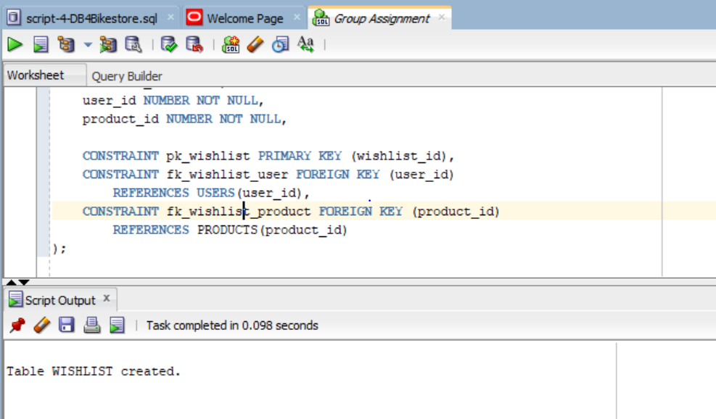
RETURNS
CREATE TABLE RETURNS (
return_id NUMBER,
order_item_id NUMBER NOT NULL,
refund_amount NUMBER(10,2) NOT NULL,
return_status VARCHAR2(30) NOT NULL,

CONSTRAINT pk_returns PRIMARY KEY (return_id),
CONSTRAINT chk_returns_refund CHECK (refund_amount >= 0),
CONSTRAINT chk_returns_status CHECK (
return_status IN ('Requested', 'Approved', 'Rejected', 'Refunded')
),
CONSTRAINT fk_returns_order_item FOREIGN KEY (order_item_id)
REFERENCES ORDER_ITEMS(order_item_id)
);
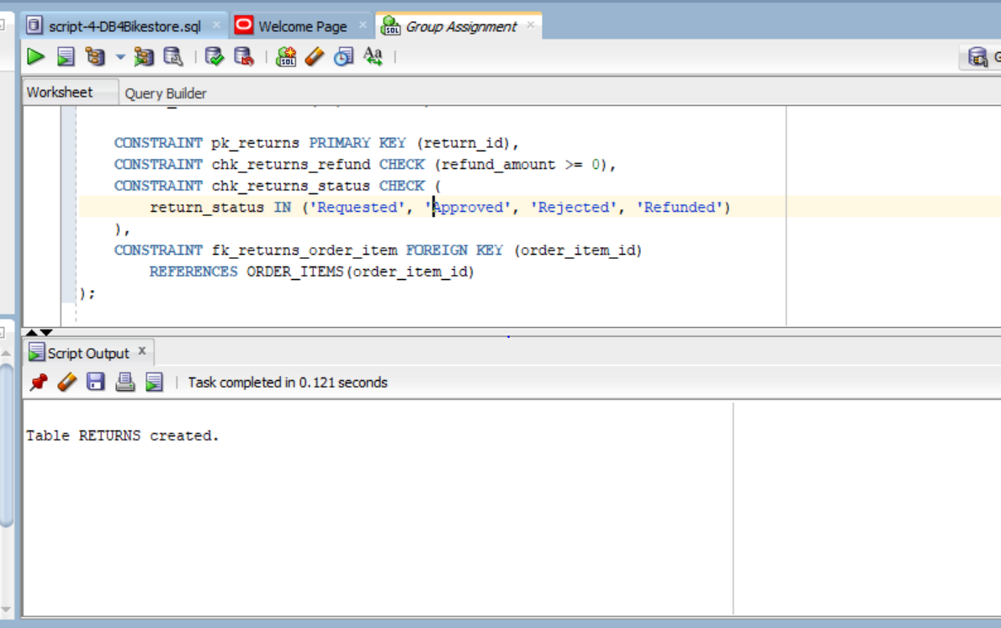
4.3 Table Verification
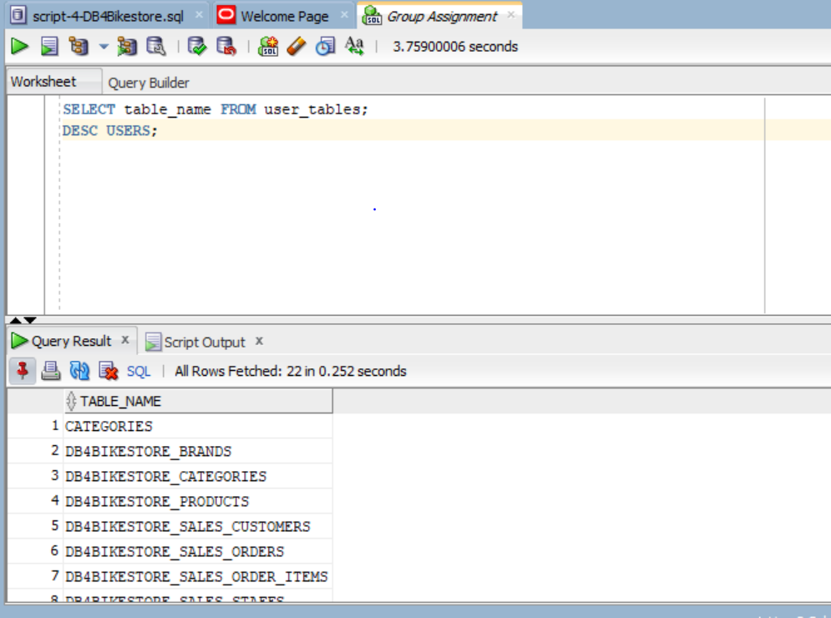
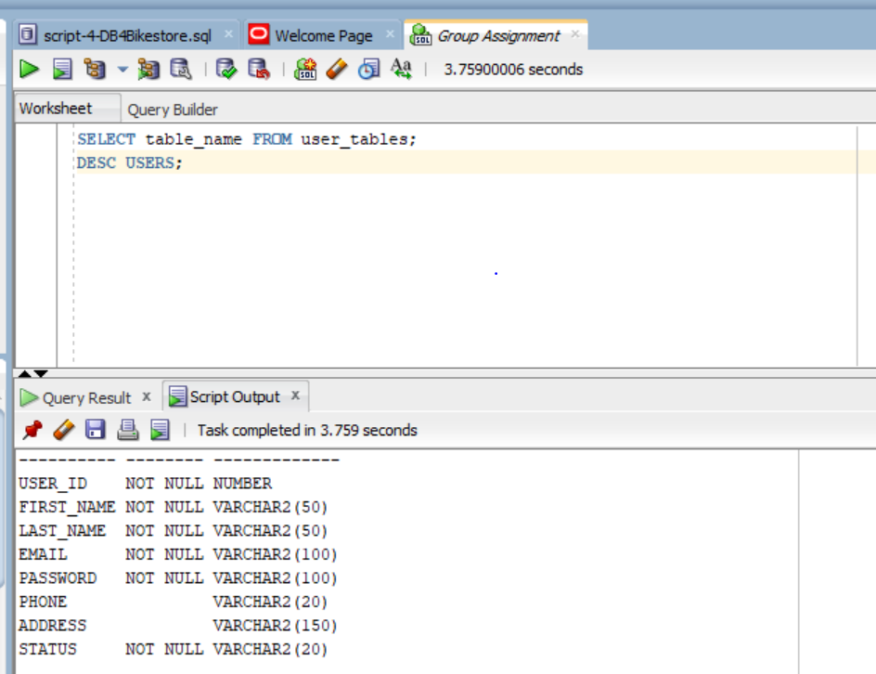
4.4 Insert Sample Data
USERS
INSERT INTO USERS VALUES (1,'Janet','Adewusi','janet@email.com','pass','1111111111','Toronto','Active');
INSERT INTO USERS VALUES (2,'John','Smith','john@email.com','pass','2222222222','Toronto','Active');
INSERT INTO USERS VALUES (3,'Mary','Lee','mary@email.com','pass','3333333333','Ajax','Inactive');
INSERT INTO USERS VALUES (4,'David','Brown','david@email.com','pass','4444444444','Whitby','Active');
INSERT INTO USERS VALUES (5,'Grace','Kim','grace@email.com','pass','5555555555','Pickering','Active');
INSERT INTO USERS VALUES (6,'Daniel','White','daniel@email.com','pass','6666666666','Toronto','Inactive');
INSERT INTO USERS VALUES (7,'Emma','Green','emma@email.com','pass','7777777777','Ajax','Active');
INSERT INTO USERS VALUES (8,'Chris','Hall','chris@email.com','pass','8888888888','Whitby','Active');
INSERT INTO USERS VALUES (9,'Sophia','King','sophia@email.com','pass','9999999999','Toronto','Active');
INSERT INTO USERS VALUES (10,'Liam','Scott','liam@email.com','pass','1010101010','Ajax','Inactive');
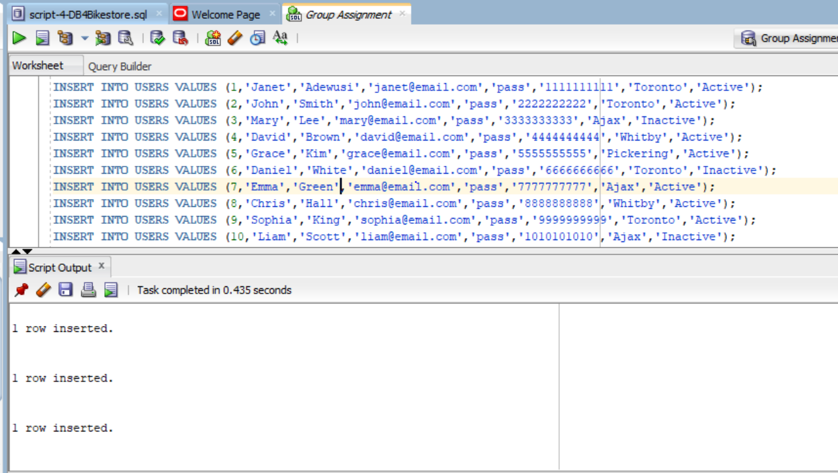
CATEGORIES
INSERT INTO CATEGORIES VALUES (1,'Hair');
INSERT INTO CATEGORIES VALUES (2,'Skin Care');
INSERT INTO CATEGORIES VALUES (3,'Makeup');
INSERT INTO CATEGORIES VALUES (4,'Accessories');
INSERT INTO CATEGORIES VALUES (5,'Electronics');
INSERT INTO CATEGORIES VALUES (6,'Clothing');
INSERT INTO CATEGORIES VALUES (7,'Shoes');
INSERT INTO CATEGORIES VALUES (8,'Bags');
INSERT INTO CATEGORIES VALUES (9,'Wigs');
INSERT INTO CATEGORIES VALUES (10,'Tools');
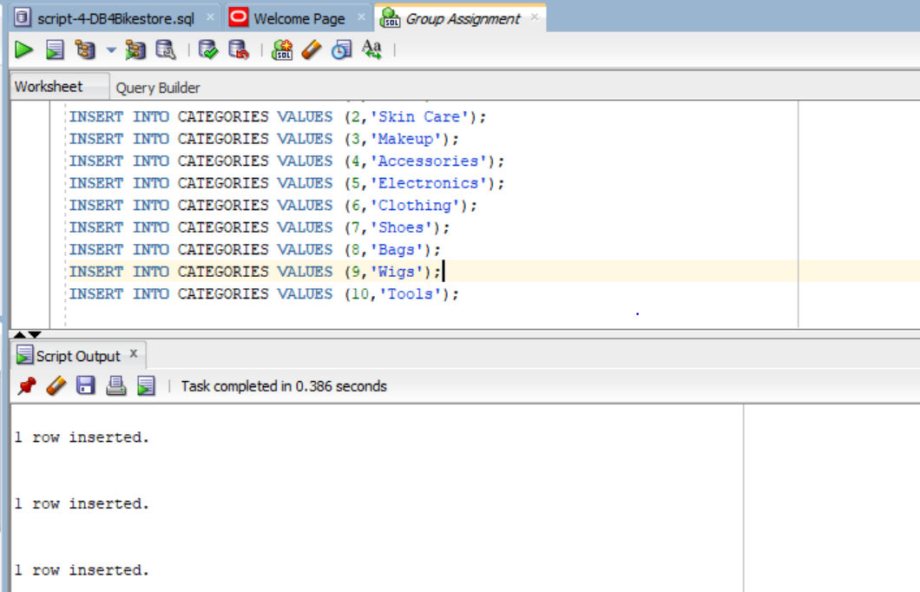
VENDORS
INSERT INTO VENDORS VALUES (1,'BeautyCo','Anna','111','a@email.com','Toronto','Active');
INSERT INTO VENDORS VALUES (2,'Glow Ltd','Ben','222','b@email.com','Ajax','Active');
INSERT INTO VENDORS VALUES (3,'HairHub','Chris','333','c@email.com','Whitby','Active');
INSERT INTO VENDORS VALUES (4,'Style Inc','Diana','444','d@email.com','Pickering','Active');
INSERT INTO VENDORS VALUES (5,'Trend Co','Evan','555','e@email.com','Toronto','Active');
INSERT INTO VENDORS VALUES (6,'FashionX','Fiona','666','f@email.com','Ajax','Active');
INSERT INTO VENDORS VALUES (7,'LuxStore','George','777','g@email.com','Whitby','Active');
INSERT INTO VENDORS VALUES (8,'UrbanWear','Holly','888','h@email.com','Toronto','Active');
INSERT INTO VENDORS VALUES (9,'TechWorld','Ian','999','i@email.com','Toronto','Active');
INSERT INTO VENDORS VALUES (10,'EliteShop','Jane','101','j@email.com','Ajax','Active');
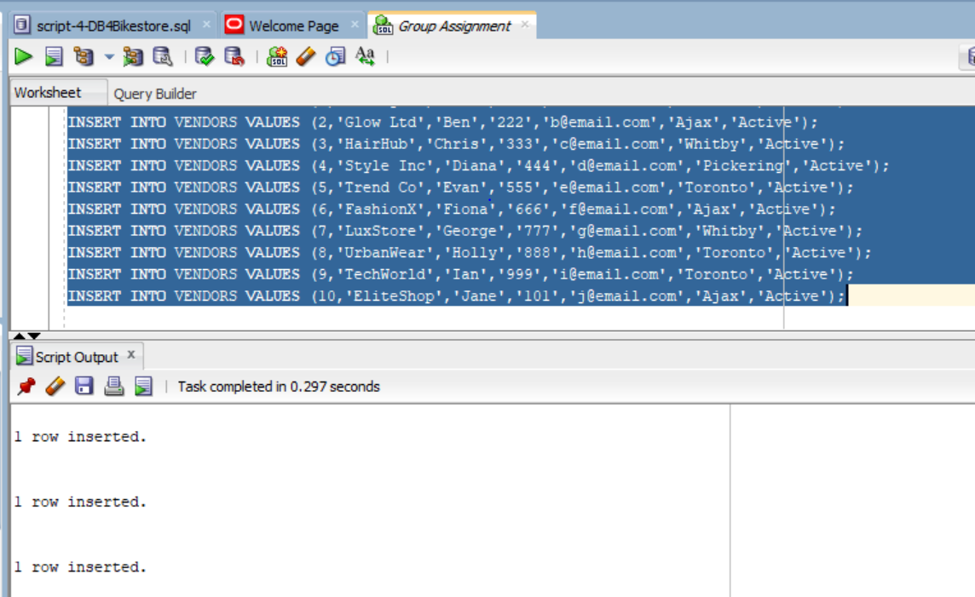
PRODUCTS
INSERT INTO PRODUCTS VALUES (1,'Wig',100,9,1);
INSERT INTO PRODUCTS VALUES (2,'Cream',20,2,2);
INSERT INTO PRODUCTS VALUES (3,'Lipstick',15,3,3);
INSERT INTO PRODUCTS VALUES (4,'Bag',50,8,4);
INSERT INTO PRODUCTS VALUES (5,'Phone',500,5,9);
INSERT INTO PRODUCTS VALUES (6,'Dress',80,6,5);
INSERT INTO PRODUCTS VALUES (7,'Shoes',60,7,6);
INSERT INTO PRODUCTS VALUES (8,'Mirror',25,10,7);
INSERT INTO PRODUCTS VALUES (9,'Hair Oil',30,1,3);
INSERT INTO PRODUCTS VALUES (10,'Clip',10,4,8);
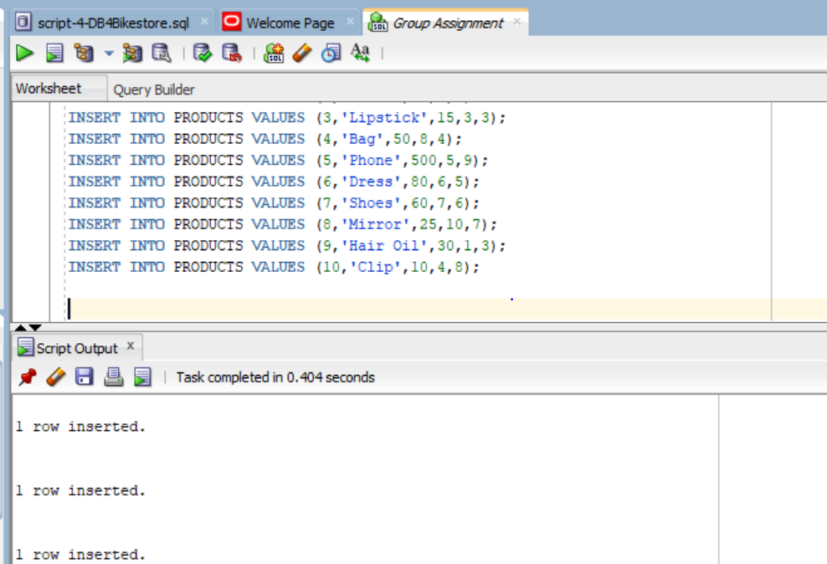
ORDERS
INSERT INTO ORDERS VALUES (1,1,SYSDATE,120,'Pending');
INSERT INTO ORDERS VALUES (2,2,SYSDATE,50,'Shipped');
INSERT INTO ORDERS VALUES (3,3,SYSDATE,70,'Delivered');
INSERT INTO ORDERS VALUES (4,4,SYSDATE,30,'Pending');
INSERT INTO ORDERS VALUES (5,5,SYSDATE,90,'Delivered');
INSERT INTO ORDERS VALUES (6,6,SYSDATE,200,'Cancelled');
INSERT INTO ORDERS VALUES (7,7,SYSDATE,150,'Shipped');
INSERT INTO ORDERS VALUES (8,8,SYSDATE,60,'Pending');
INSERT INTO ORDERS VALUES (9,9,SYSDATE,40,'Delivered');
INSERT INTO ORDERS VALUES (10,10,SYSDATE,110,'Pending');
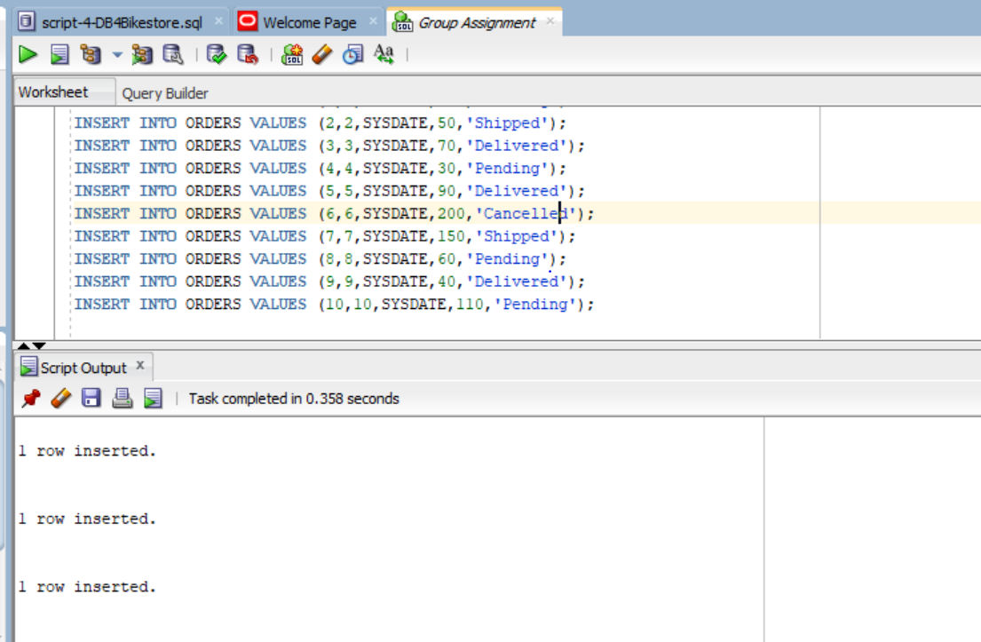
ORDER_ITEMS
INSERT INTO ORDER_ITEMS VALUES (1,1,1,2);
INSERT INTO ORDER_ITEMS VALUES (2,2,2,1);
INSERT INTO ORDER_ITEMS VALUES (3,3,3,3);
INSERT INTO ORDER_ITEMS VALUES (4,4,4,1);
INSERT INTO ORDER_ITEMS VALUES (5,5,5,1);
INSERT INTO ORDER_ITEMS VALUES (6,6,6,2);
INSERT INTO ORDER_ITEMS VALUES (7,7,7,1);
INSERT INTO ORDER_ITEMS VALUES (8,8,8,2);
INSERT INTO ORDER_ITEMS VALUES (9,9,9,1);
INSERT INTO ORDER_ITEMS VALUES (10,10,10,3);
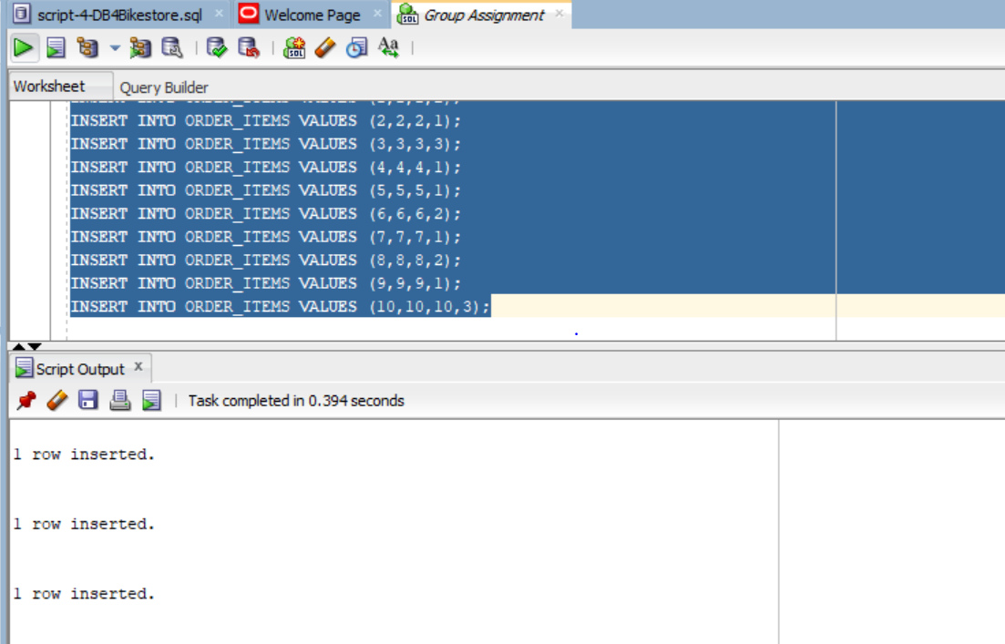
WISHLIST
INSERT INTO WISHLIST VALUES (1,1,1);
INSERT INTO WISHLIST VALUES (2,2,2);
INSERT INTO WISHLIST VALUES (3,3,3);
INSERT INTO WISHLIST VALUES (4,4,4);
INSERT INTO WISHLIST VALUES (5,5,5);
INSERT INTO WISHLIST VALUES (6,6,6);
INSERT INTO WISHLIST VALUES (7,7,7);
INSERT INTO WISHLIST VALUES (8,8,8);
INSERT INTO WISHLIST VALUES (9,9,9);
INSERT INTO WISHLIST VALUES (10,10,10);
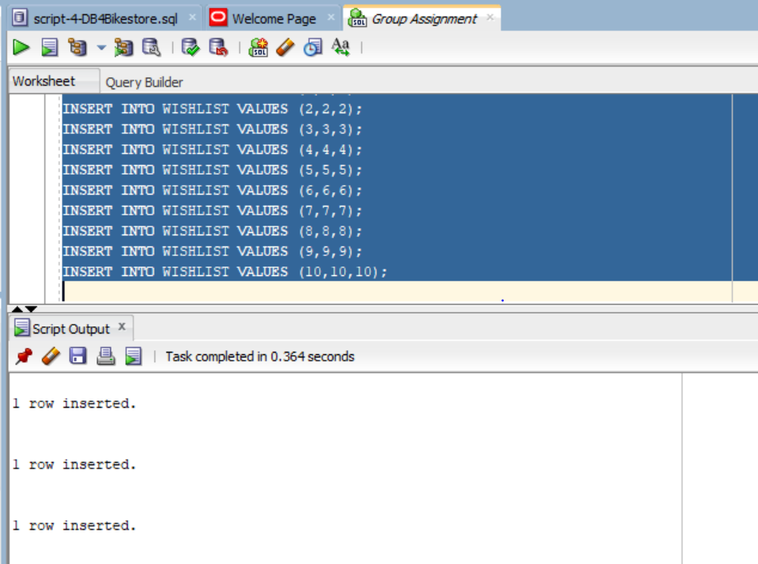
RETURNS
INSERT INTO RETURNS VALUES (1,1,50,'Approved');
INSERT INTO RETURNS VALUES (2,2,20,'Requested');
INSERT INTO RETURNS VALUES (3,3,30,'Refunded');
INSERT INTO RETURNS VALUES (4,4,10,'Rejected');
INSERT INTO RETURNS VALUES (5,5,60,'Approved');
INSERT INTO RETURNS VALUES (6,6,40,'Requested');
INSERT INTO RETURNS VALUES (7,7,25,'Refunded');
INSERT INTO RETURNS VALUES (8,8,15,'Approved');
INSERT INTO RETURNS VALUES (9,9,35,'Rejected');
INSERT INTO RETURNS VALUES (10,10,45,'Approved');
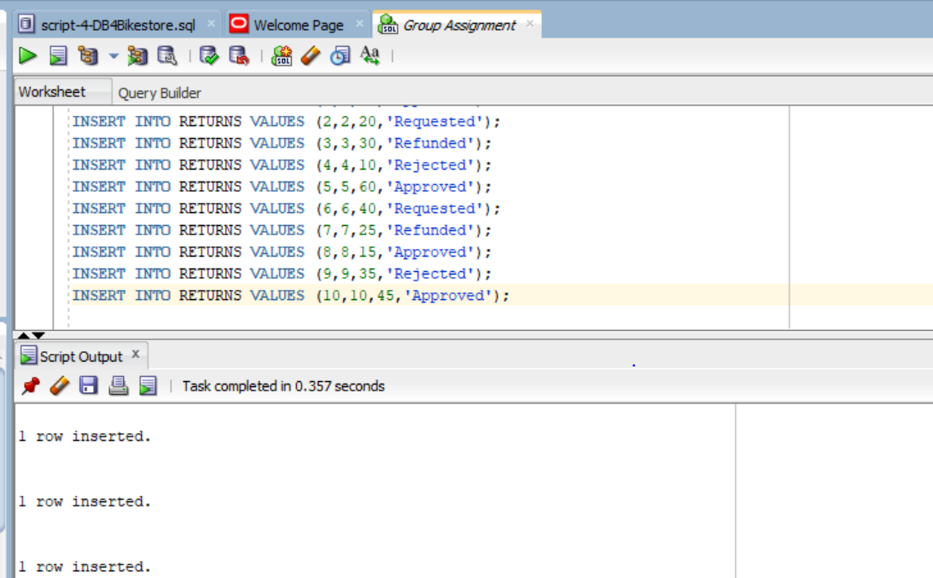
4.5 Data Verification
USERS
SELECT * FROM USERS;
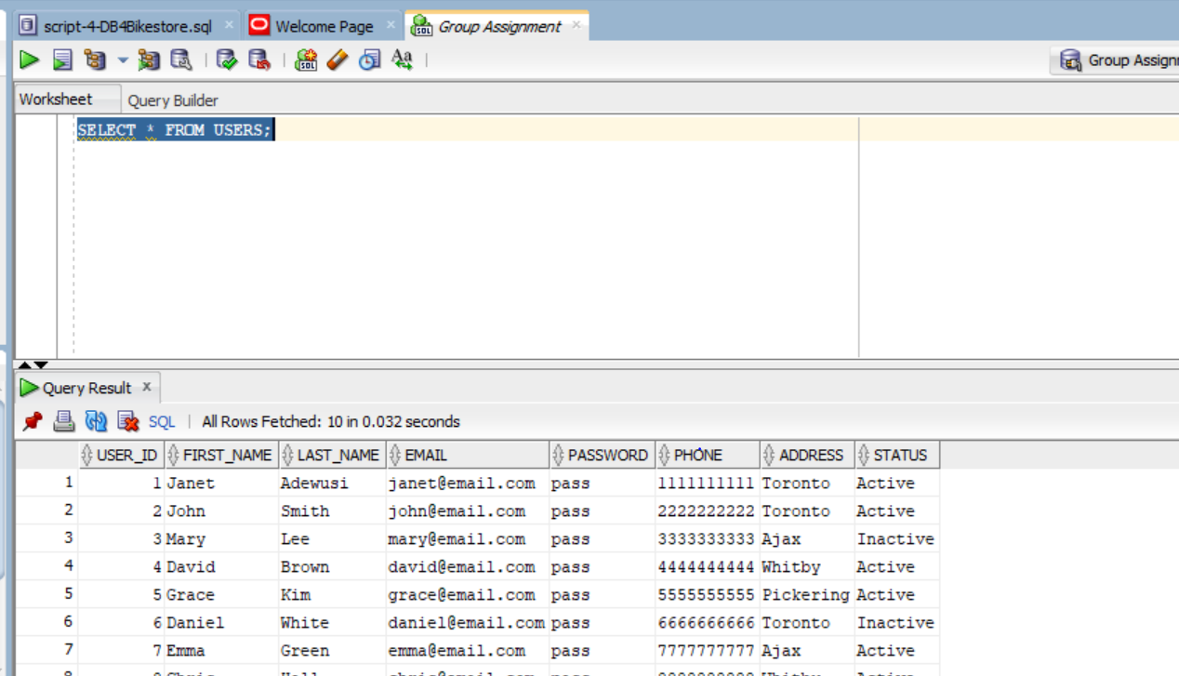
CATEGORIES
SELECT * FROM CATEGORIES;
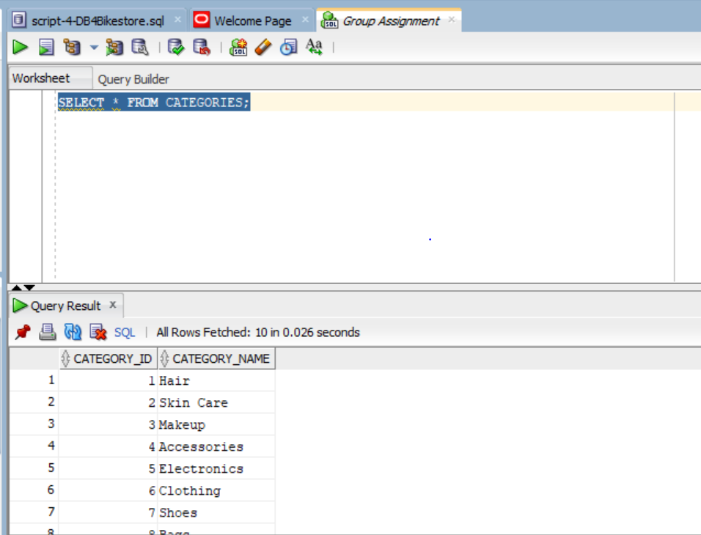
VENDORS
SELECT * FROM VENDORS;
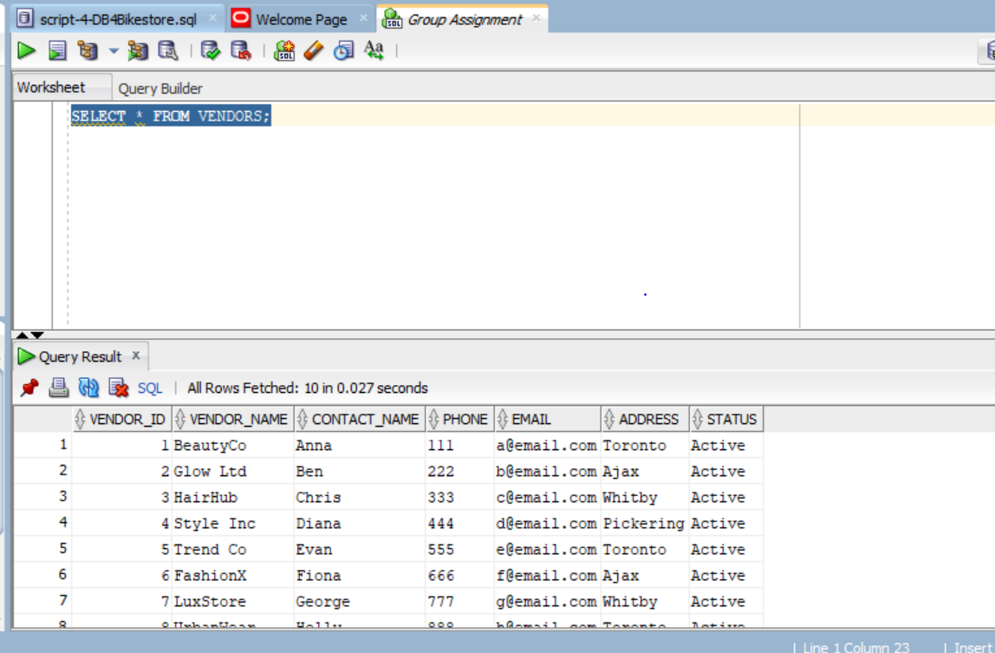
PRODUCTS
SELECT * FROM PRODUCTS;
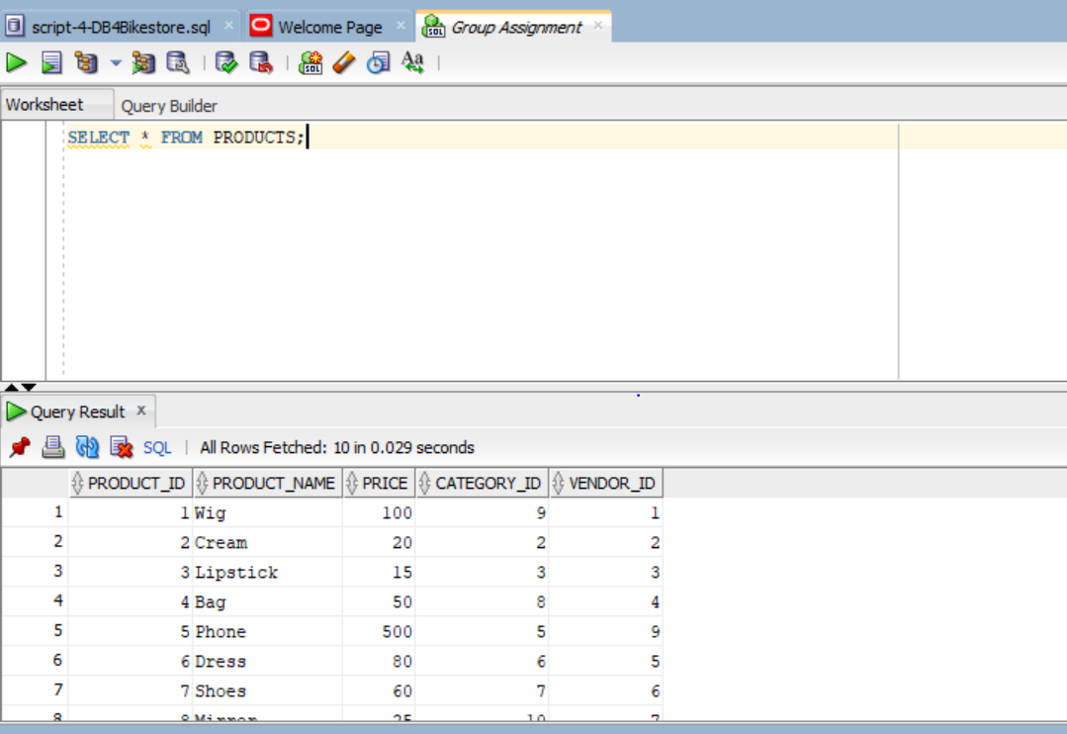
ORDERS
SELECT * FROM ORDERS;
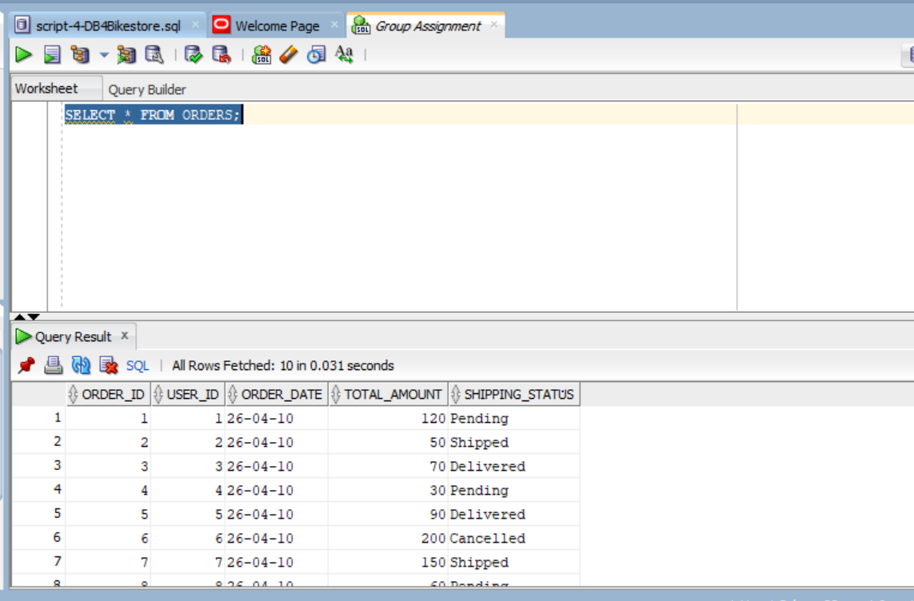
ORDER_ITEMS
SELECT * FROM ORDER_ITEMS;
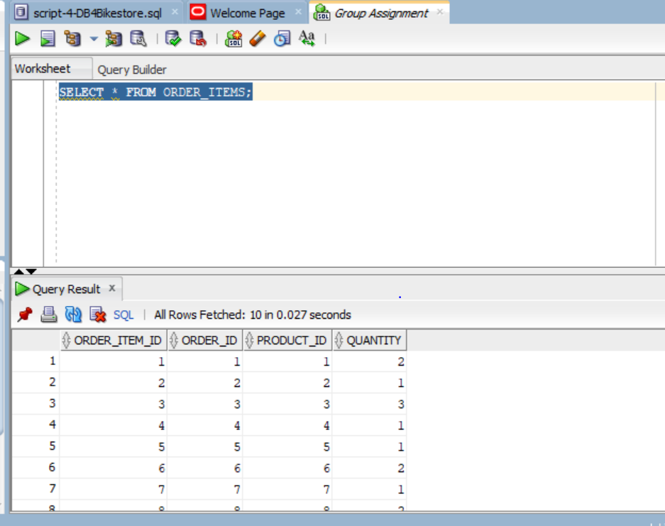
WISHLIST
SELECT * FROM WISHLIST;
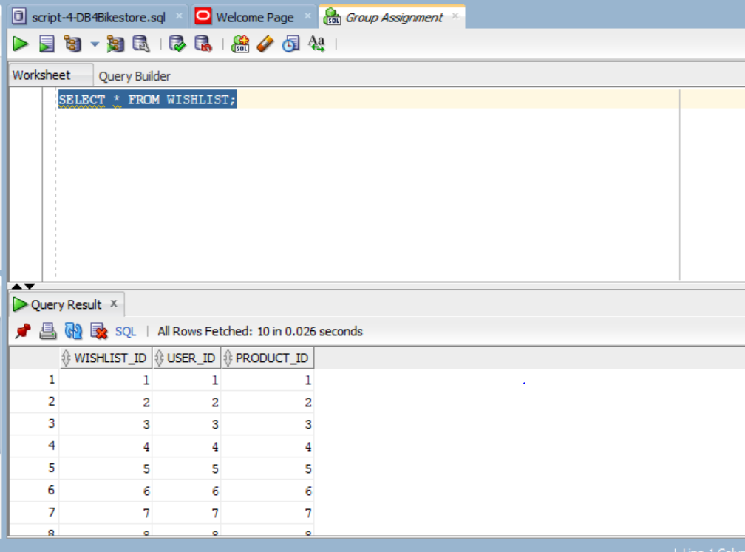
RETURNS
SELECT * FROM RETURNS;
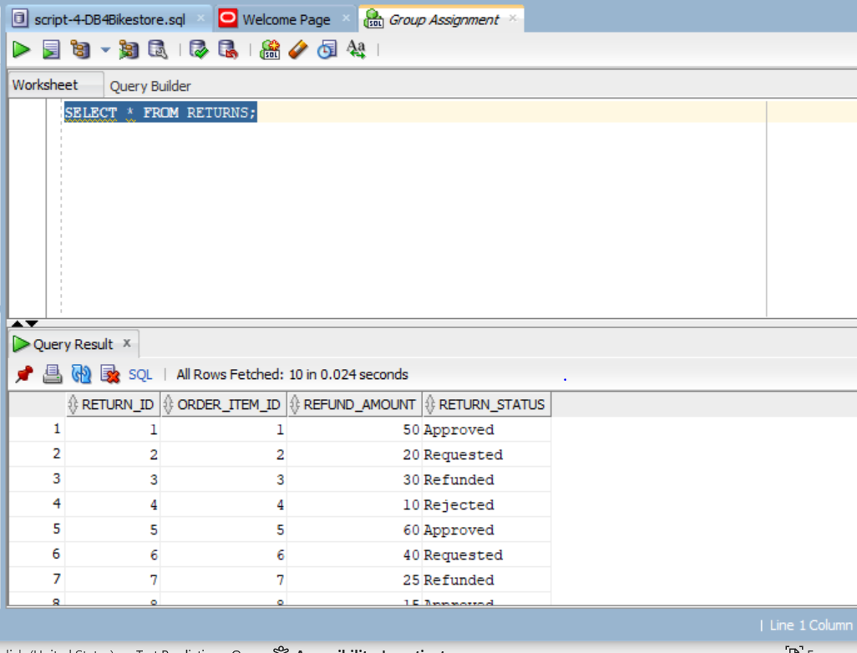
5. Business Requirement Queries

5.1 Search Products Based on Category
SELECT p.product_id, p.product_name, p.price, c.category_name
FROM PRODUCTS p
JOIN CATEGORIES c ON p.category_id = c.category_id
WHERE c.category_name = 'Hair';
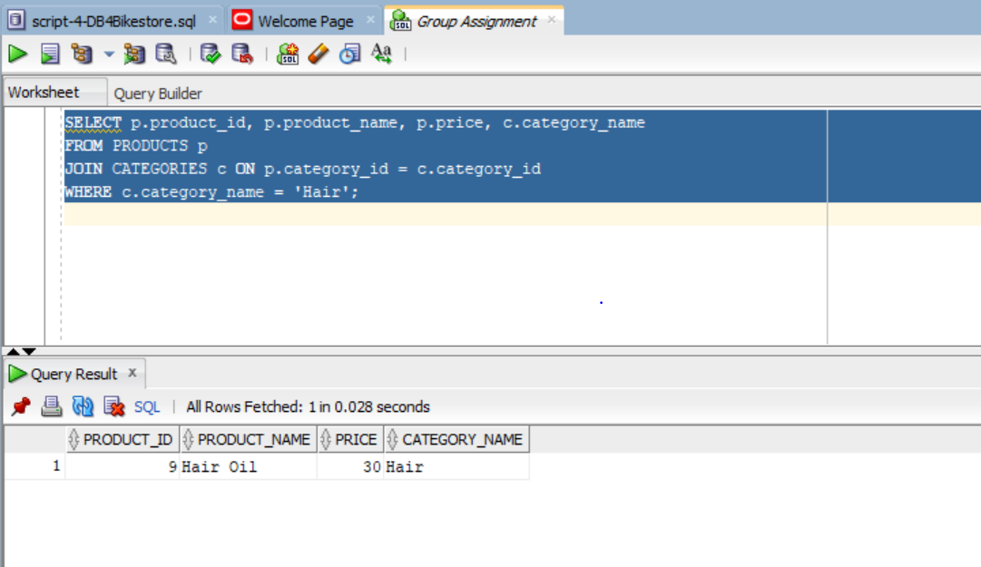
5.2 Manage Shopping Cart
SELECT o.order_id, p.product_name, oi.quantity, p.price,
(oi.quantity * p.price) AS subtotal
FROM ORDERS o
JOIN ORDER_ITEMS oi ON o.order_id = oi.order_id
JOIN PRODUCTS p ON oi.product_id = p.product_id
WHERE o.order_id = 1;
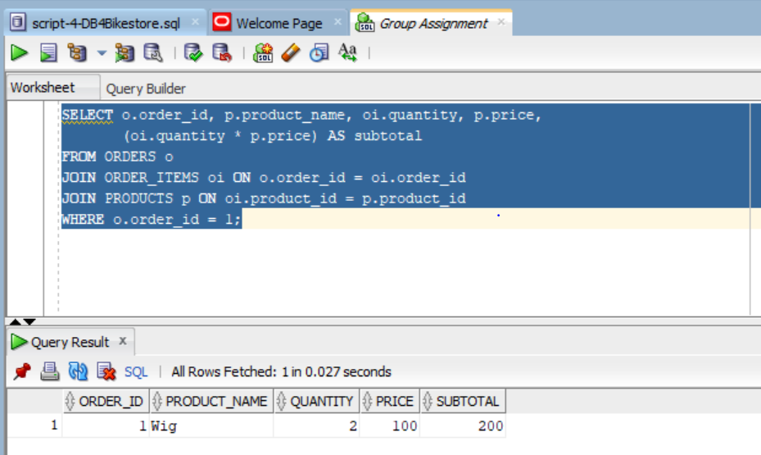
5.3 Register / Unregister User
Register user:
INSERT INTO USERS
VALUES (11, 'Sarah', 'Jones', 'sarah@email.com', 'pass123', '1212121212', 'Toronto', 'Active');
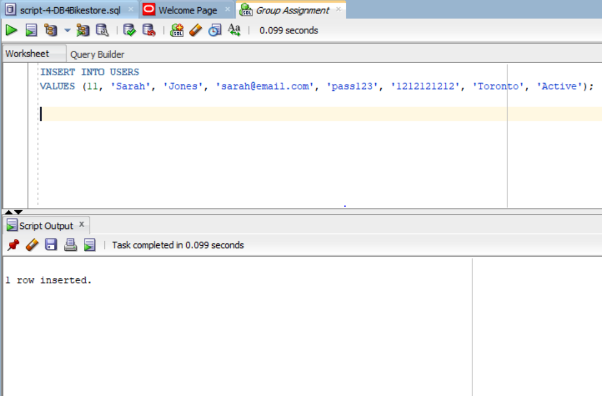
Unregister user:
UPDATE USERS
SET status = 'Inactive'
WHERE user_id = 11;
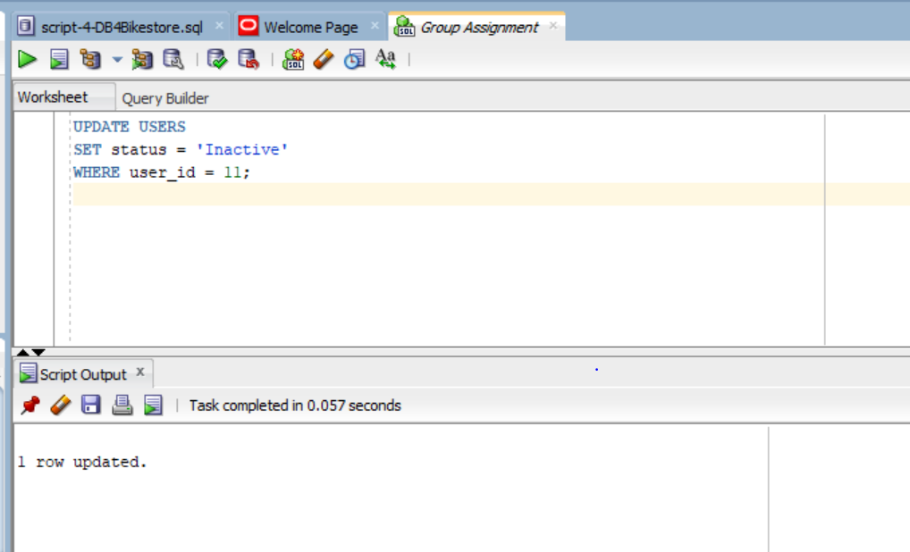
Verify
SELECT *
FROM USERS
WHERE user_id = 11;
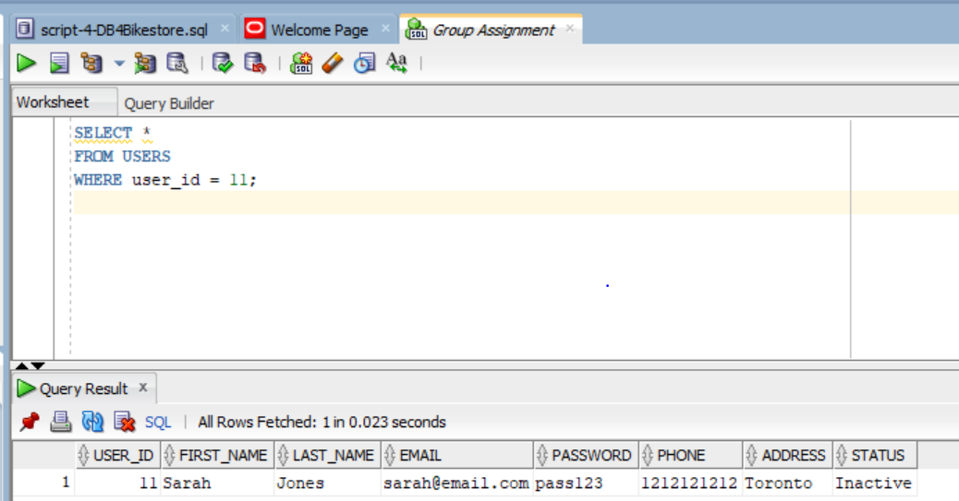
5.4 Track Shipping Status
SELECT order_id, shipping_status
FROM ORDERS
WHERE order_id = 1;
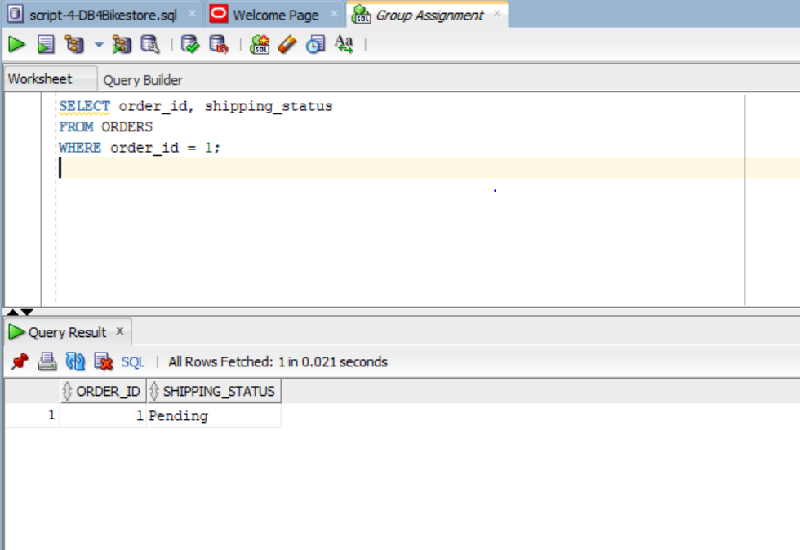
5.5 Manage Vendors
SELECT v.vendor_id, v.vendor_name, p.product_name
FROM VENDORS v
JOIN PRODUCTS p ON v.vendor_id = p.vendor_id
ORDER BY v.vendor_id;
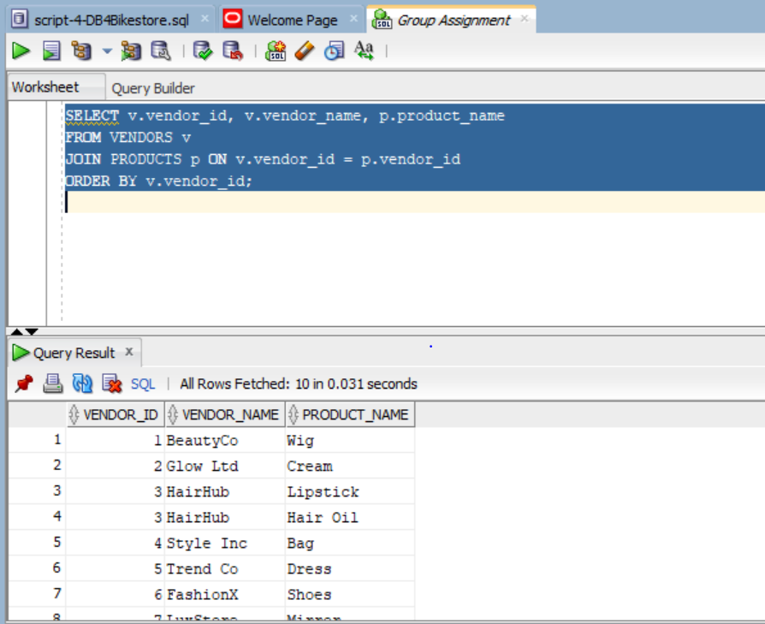
5.6 Generate Monthly Report
SELECT TO_CHAR(order_date, 'YYYY-MM') AS sales_month,
SUM(total_amount) AS total_sales
FROM ORDERS
GROUP BY TO_CHAR(order_date, 'YYYY-MM')
ORDER BY sales_month;
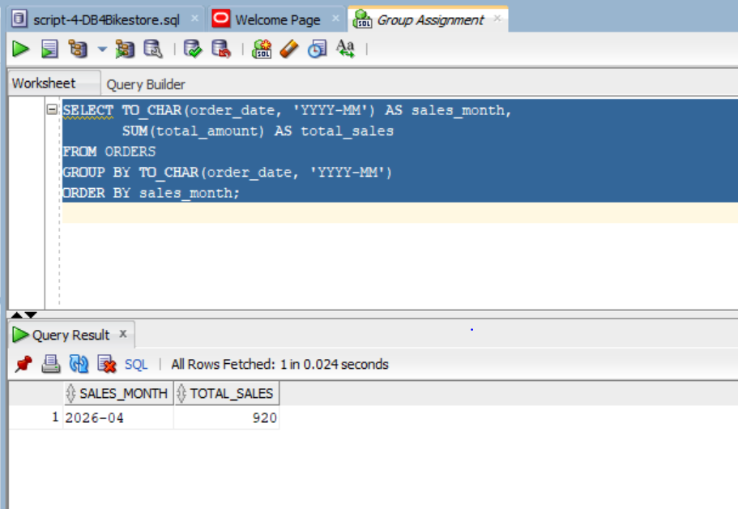
5.7 Identify the Most Popular Product(s)
SELECT p.product_name, SUM(oi.quantity) AS total_quantity
FROM ORDER_ITEMS oi
JOIN PRODUCTS p ON oi.product_id = p.product_id
GROUP BY p.product_name
HAVING SUM(oi.quantity) = (
SELECT MAX(total_qty)
FROM (
SELECT SUM(quantity) AS total_qty
FROM ORDER_ITEMS
GROUP BY product_id
)
);
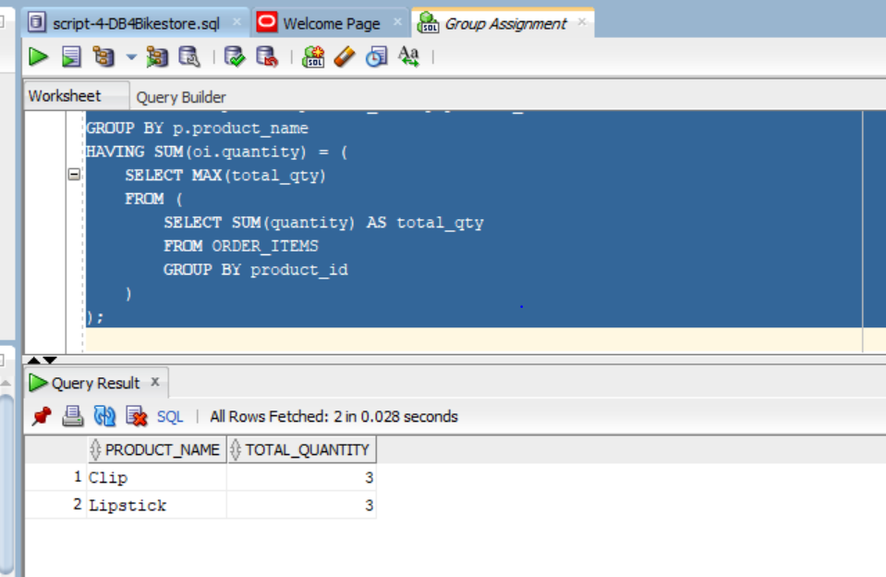
5.8 Categorize Customers Based on Purchase History
SELECT u.user_id,
u.first_name,
u.last_name,
SUM(o.total_amount) AS total_spent,
CASE
WHEN SUM(o.total_amount) >= 200 THEN 'Premium'
WHEN SUM(o.total_amount) >= 100 THEN 'Regular'
ELSE 'Occasional'
END AS customer_category
FROM USERS u
JOIN ORDERS o ON u.user_id = o.user_id
GROUP BY u.user_id, u.first_name, u.last_name
ORDER BY total_spent DESC;
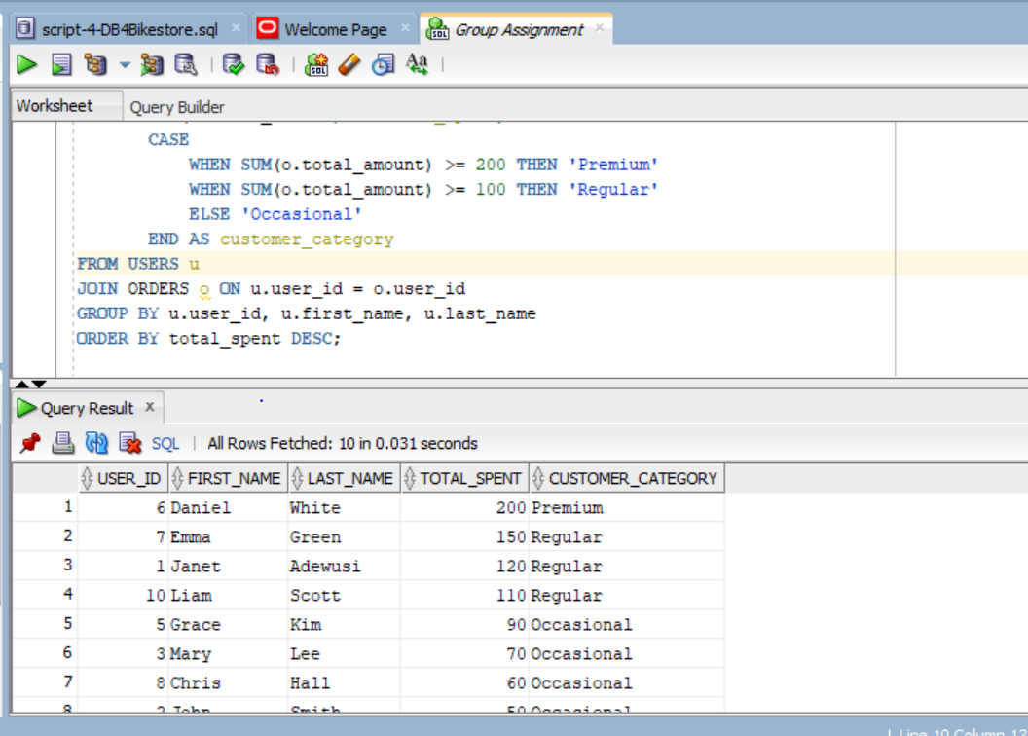
5.9 List All Items on User’s Wish List
SELECT u.first_name, u.last_name, p.product_name
FROM WISHLIST w
JOIN USERS u ON w.user_id = u.user_id
JOIN PRODUCTS p ON w.product_id = p.product_id
WHERE u.user_id = 1;
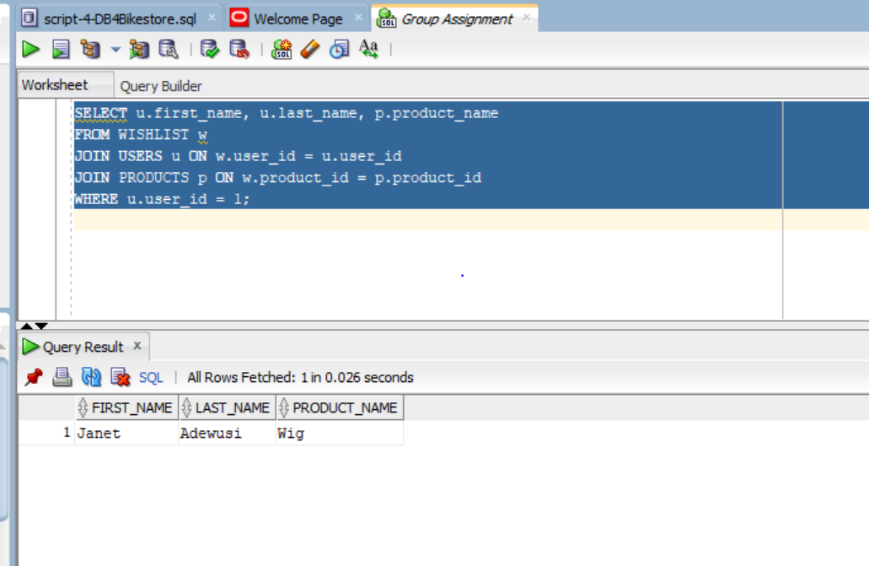
5.10 Handle Returns and Refunds
SELECT r.return_id, p.product_name, r.refund_amount, r.return_status
FROM RETURNS r
JOIN ORDER_ITEMS oi ON r.order_item_id = oi.order_item_id
JOIN PRODUCTS p ON oi.product_id = p.product_id
ORDER BY r.return_id;


